Wednesday Pack
Akua Gye Nyame Mug
https://www.amazon.com/dp/B0H5BM22NV
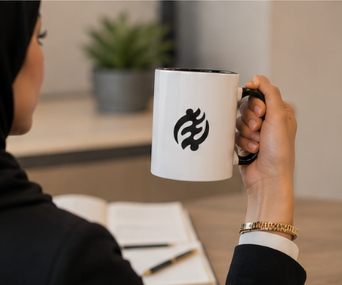
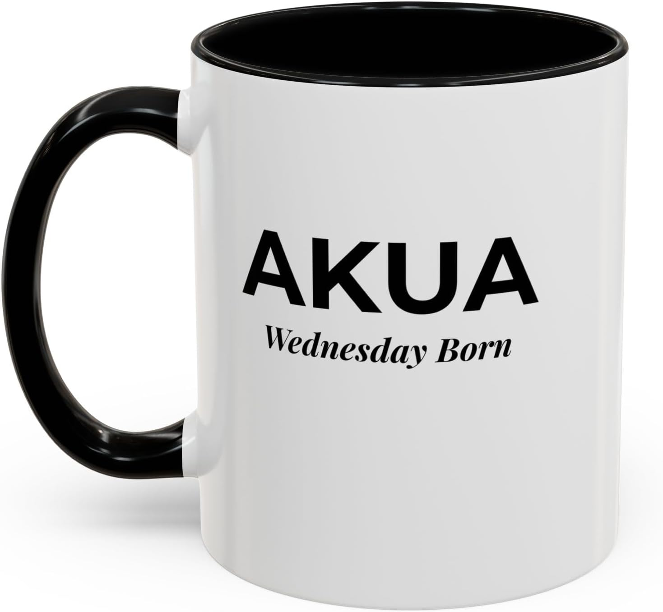
Akua Sankofa Mug
https://www.amazon.com/dp/B0H5BLBGRF

Kwaku Sankofa Mug
https://www.amazon.com/dp/B0H5BKJS7B
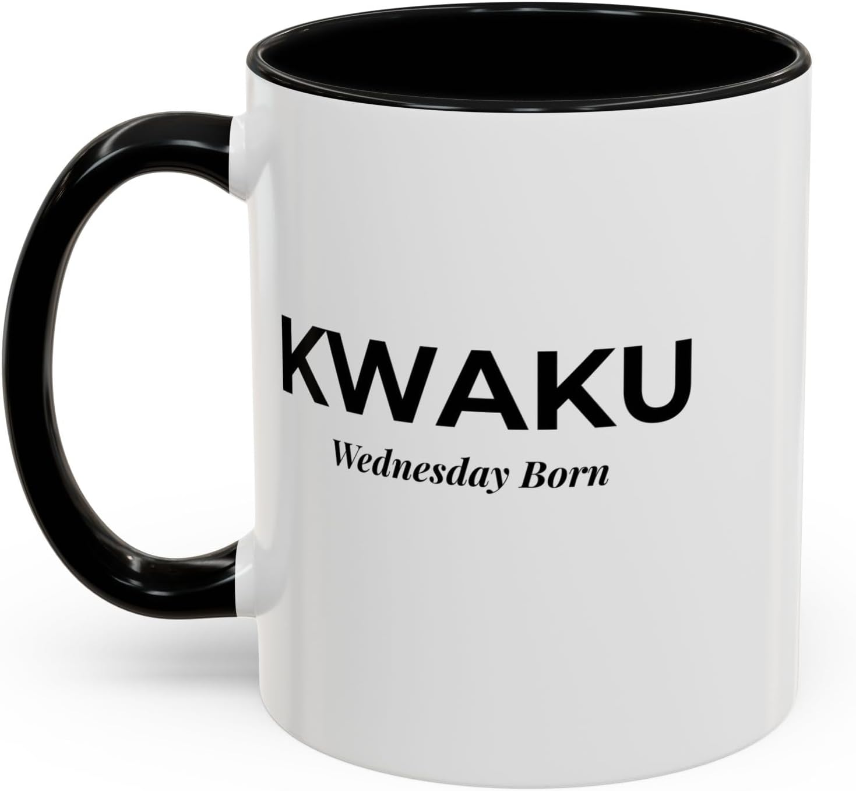
Kwaku Gye Nyame Mug
https://www.amazon.com/dp/B0H5BLYVXY

Akua Baby Onesie
https://www.amazon.com/dp/B0H59R8Y9K?th=1&psc=1

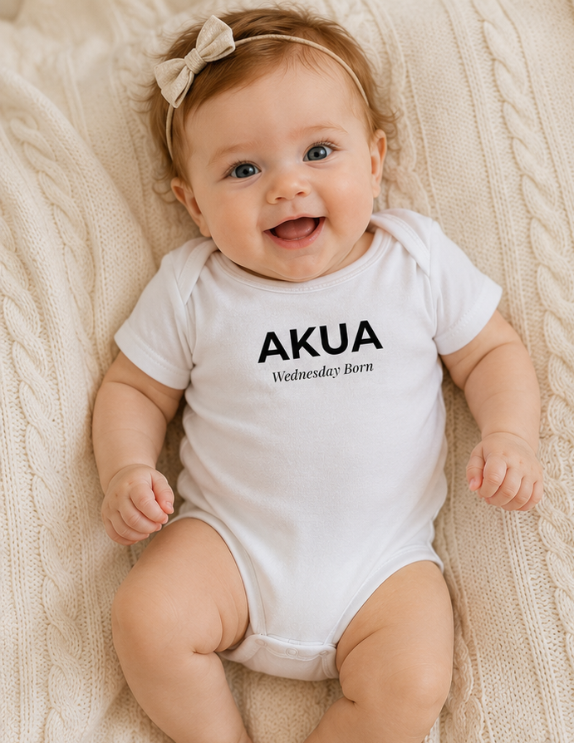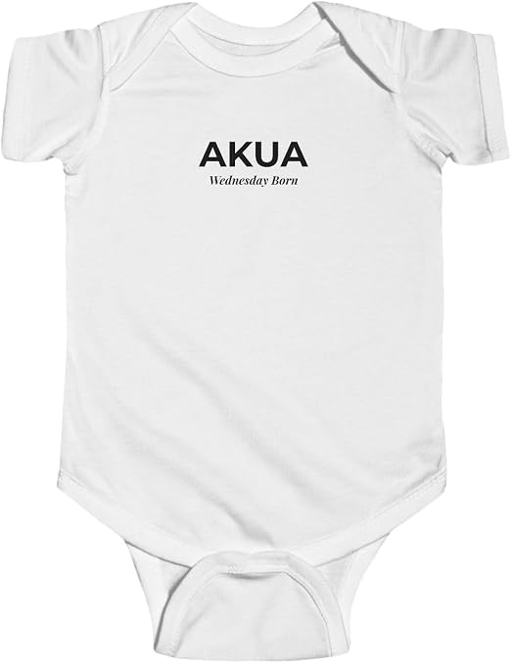
Kwaku Baby Onesie
https://www.amazon.com/dp/B0H5CXKVSN?th=1&psc=1
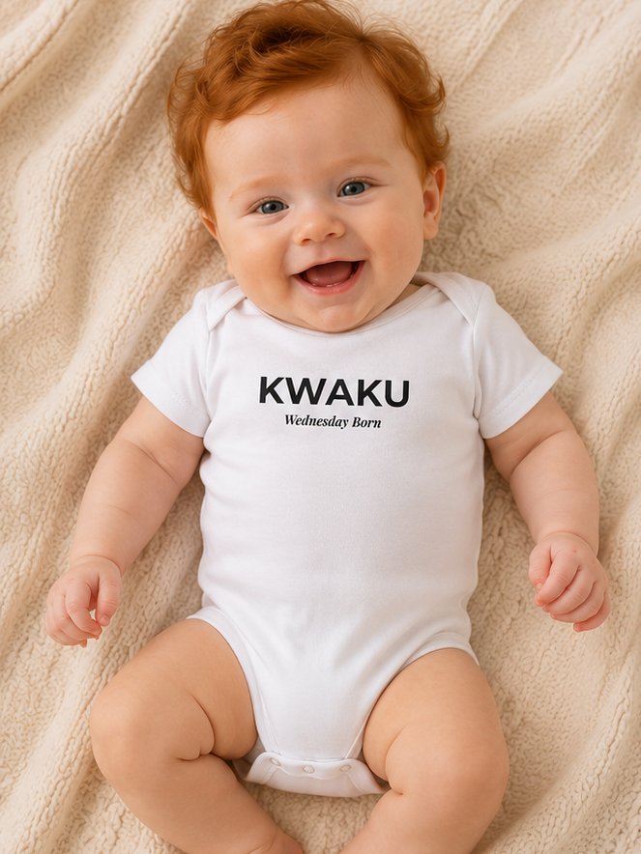

Akua Sankofa Back
https://www.amazon.com/dp/B0H3HZ5W8V?th=1&psc=1
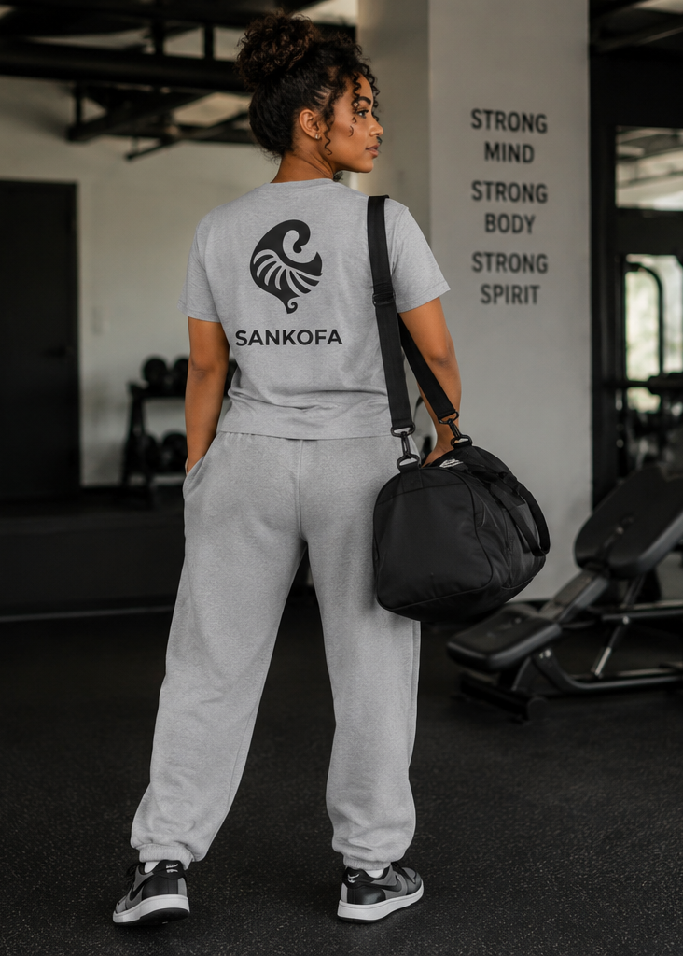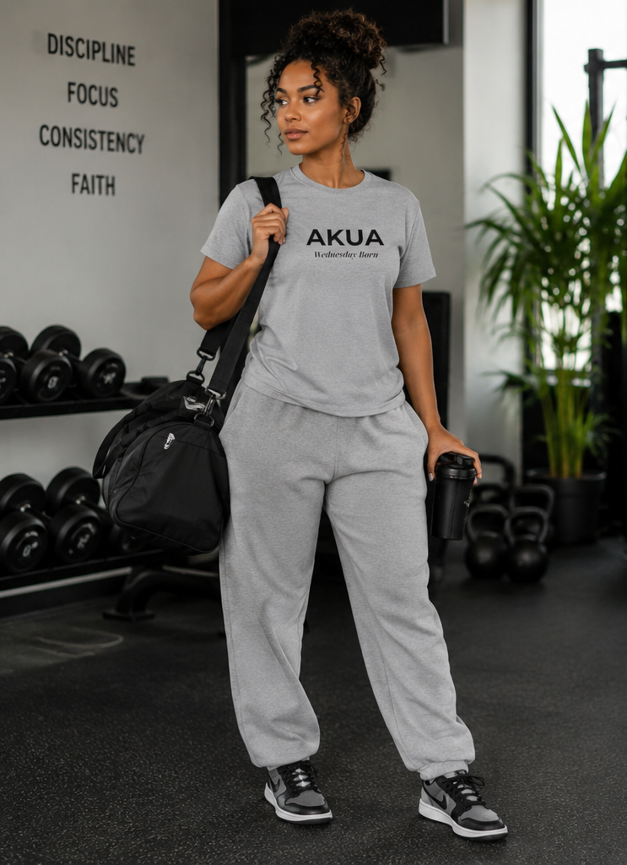
Akua Gye Nyame Back
https://www.amazon.com/dp/B0H3J6QJ16?th=1&psc=1
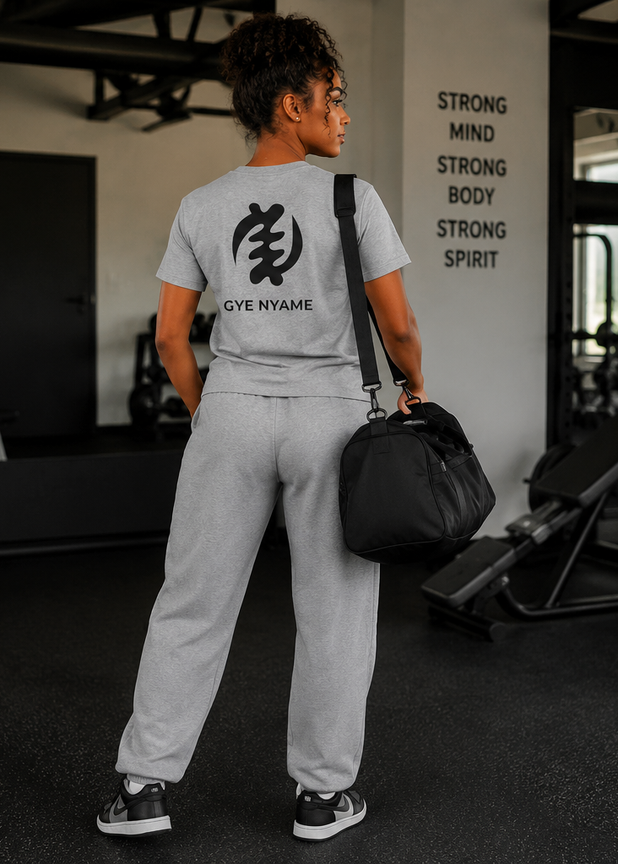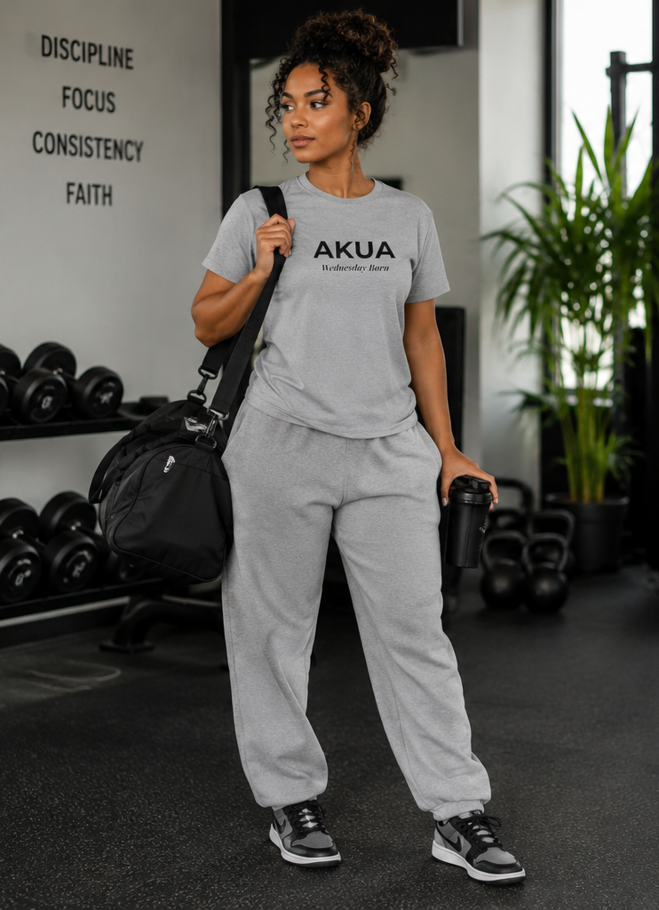
Kwaku Sankofa Back
https://www.amazon.com/dp/B0H58X1PW4?th=1&psc=1
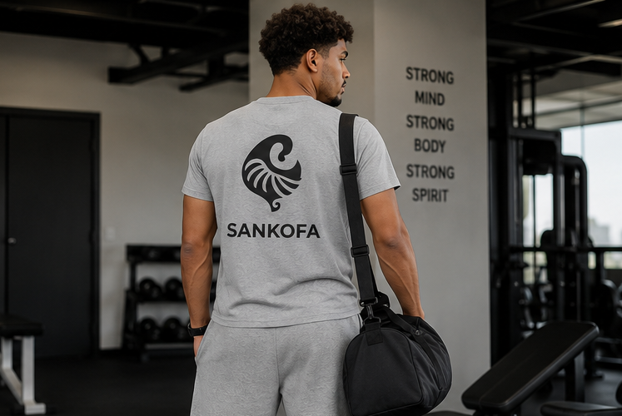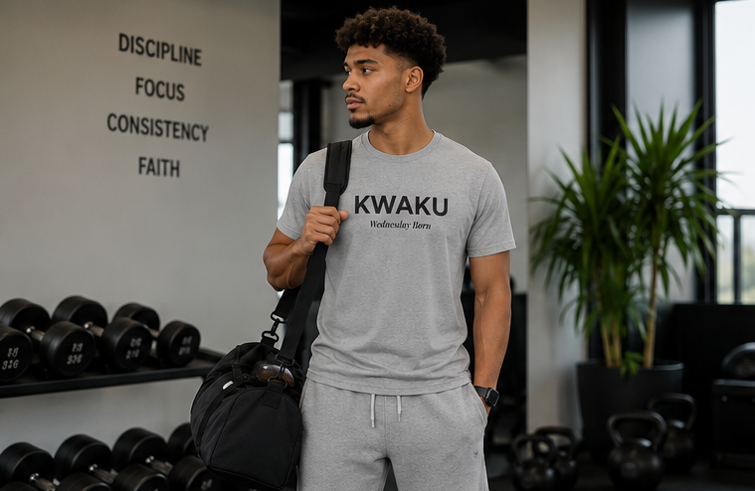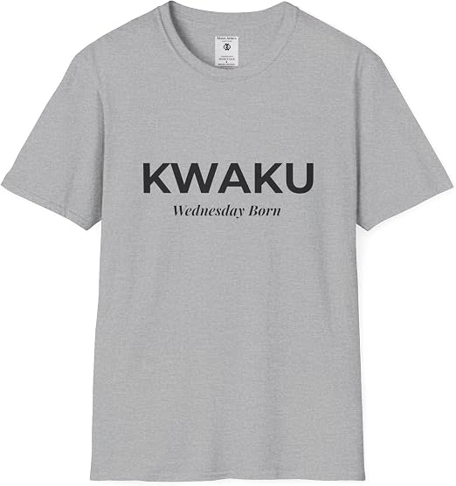
Kwaku Gye Nyame Back
https://www.amazon.com/dp/B0H3JHCZDZ?th=1&psc=1
